## 1. Filtering numbers

Welcome back! Now that we've mastered selecting and counting data from a database, we'll add to our repertoire by learning about filtering.

## 2. WHERE

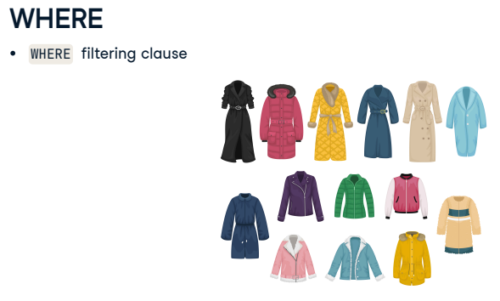To filter, we need to use a new clause called WHERE, which allows us to focus on only the data relevant to our business questions. Going back to our coat analogy, we may want to select a coat from the closet

## 3. WHERE

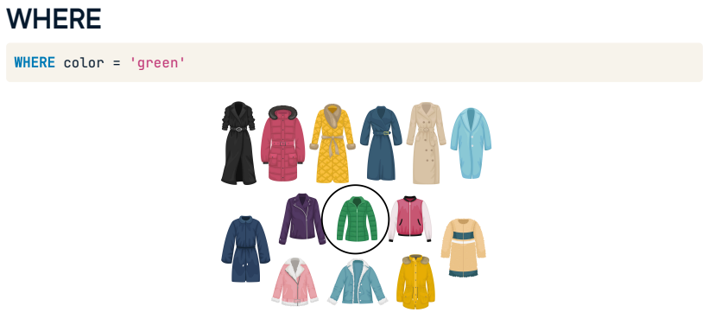where the color is green. The WHERE clause can help us with that.

## 4. WHERE with comparison operators

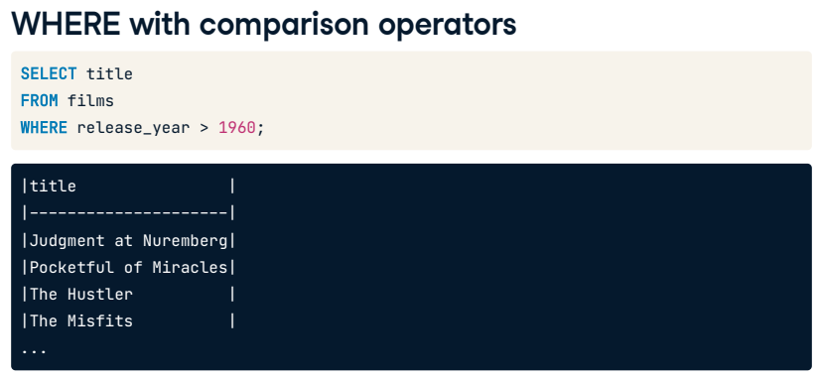We will focus on filtering numbers in this lesson. To do this, we will be using comparison operators such as greater than. Here is an example of a query where we filtered to see only films released after the year 1960 using the greater than operator.

## 5. Comparison operators

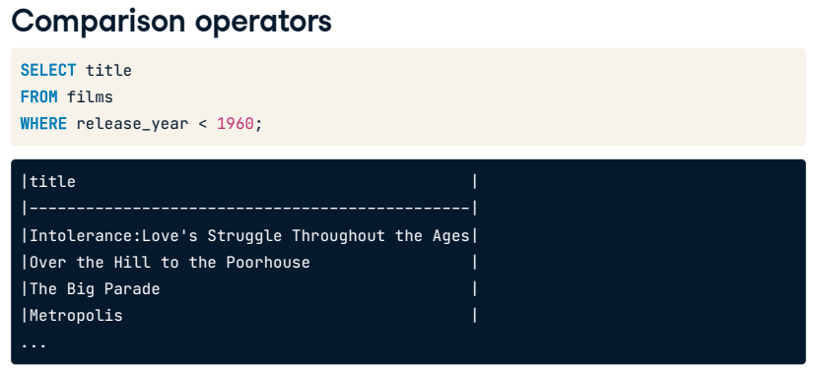Let's explore some of the other operators. We would use the less-than operator to see films released before the year 1960.

## 6. Comparison operators

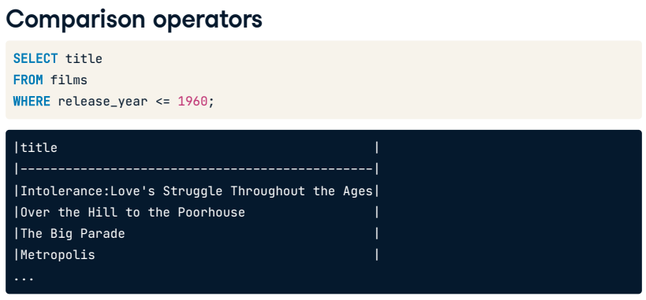We would use the less than or equal to operator to see films released during or before the year 1960.

## 7. Comparison operators

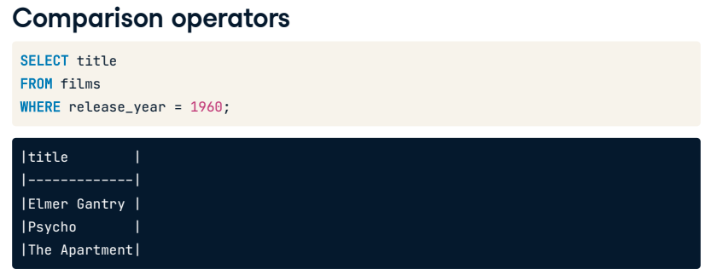If we want to see films released in a specific year, we can use equals.

## 8. Comparison operators

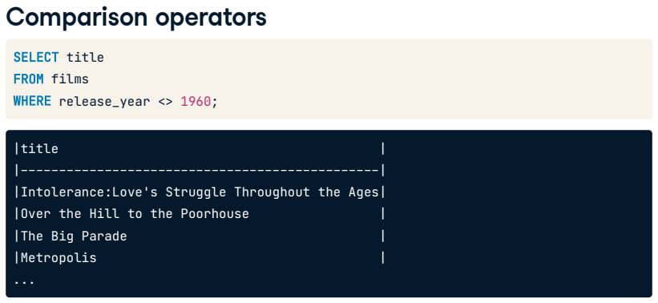Here is a final example that isn't as intuitive as the others. If we wanted to filter films to see all releases EXCEPT those from the year 1960, we would combine the less than and greater than symbols as shown here. This is the SQL standard symbol that means "not equal to".

## 9. Comparison operators

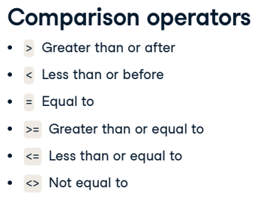

Let's recap all the comparison operators we can use with WHERE to filter numbers. We have: greater than (that also means after), less than (that also means before), equal to, greater than or equal to, less than or equal to, and not equal to.

## 10. WHERE with strings

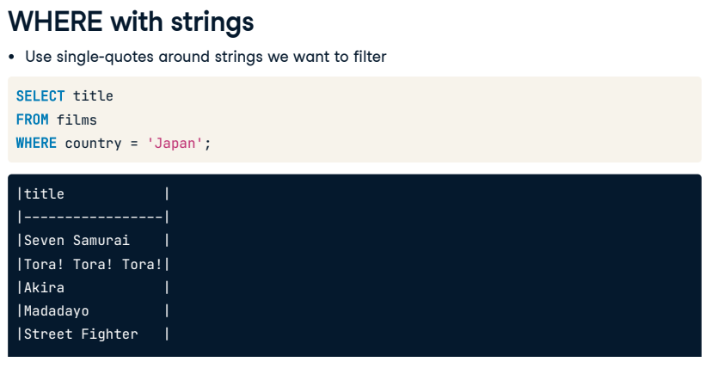WHERE and the comparison operator, equals, can also be used with strings. In these cases, we will have to use single quotation marks around the strings we want to filter. For example, here, we want to filter titles where the country is Japan.

## 11. Order of execution

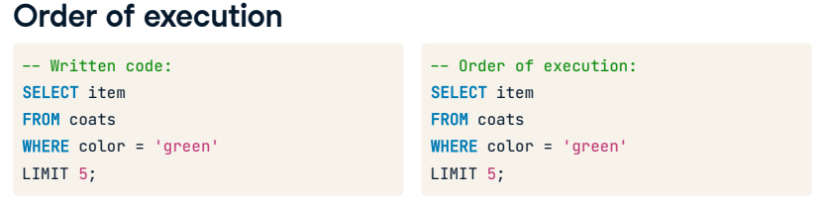A final note on using WHERE. Similar to LIMIT, this clause comes after the FROM statement when writing a query. If we use both WHERE and LIMIT, the written order will be SELECT, FROM, WHERE, LIMIT; however, the order of execution will now be FROM, WHERE, SELECT, LIMIT. Thinking about the coats in our closet, we go to the closet we want to get the coat from, find where the green coats are, and select five of them.

## 12. Let's practice!

Ok, now it's time for practice!

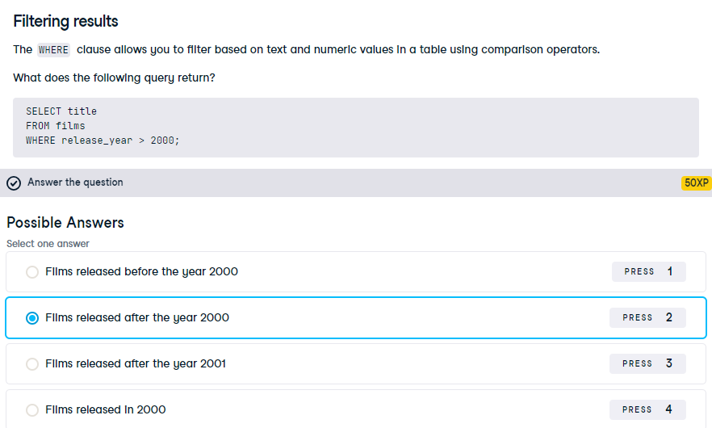

Correct! Our query will return films that were released after the year 2000.

## Exercise

# Using WHERE with numbers

Filtering with WHERE allows you to analyze your data better. You may have a dataset that includes a range of different movies, and you need to do a case study on the most notable films with the biggest budgets. In this case, you'll want to filter your data to a specific budget range.

Now it's your turn to use the WHERE clause to filter numeric values!

## Instructions 1/3

1. Select the film_id and imdb_score from the reviews table and filter on scores higher than 7.0.
2. 2. Select the film_id and facebook_likes of the first ten records with less than 1000 likes from the reviews table.
3. [3.](javascript:void(0)) Count how many records have a num_votes of at least 100,000; use the alias films_over_100K_votes.

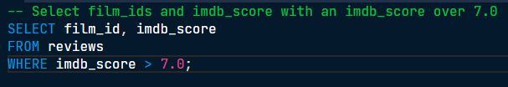

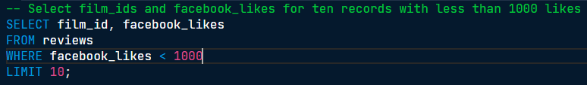

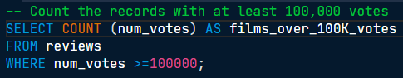

Well done! Applying a WHERE filter with SQL is much easier and faster than scrolling through a spreadsheet or using a highlighter!

## Exercise

# Using WHERE with text

WHERE can also filter string values.

Imagine you are part of an organization that gives cinematography awards, and you have several international categories. Before you confirm an award for every language listed in your dataset, it may be worth seeing if there are enough films of a specific language to make it a fair competition. If there is only one movie or a significant skew, it may be worth considering a different way of giving international awards.

Let's try this out!

## Instructions

* Select and count the language field using the alias count_spanish.
* Apply a filter to select only Spanish from the language field.

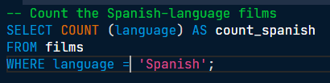

Bien hecho! Well done! There are 40 Spanish-language films in this table.